King Fahd University of Petroleum and Minerals
Information and Computer Science Department

ICS 103: Computer Programming in C
Fall Semester 2007-2008 (Term-071)

Final Exam

Time:120 minutes Sunday, January 27, 2008

Name:
ID#:

PLEASE CIRCLE YOUR SECTION BELOW:
Section | 01 | 02 | 03 | 04 | 05 | 06
Time | UT-9-9:50am | UT-8-8:50am | UT-10-10:50am | UT-11-11:50am | UT-1:10-2pm | SM-9-9:50am
Note:

- Copying or Discussion will result in zero grade for all the students involved.
- Attempt all questions.

Question # | Maximum Marks | Obtained Marks
Q1P1+Q1P2 | 6+6=12
Q1P3+Q1 P4 | 8+8=16
Q1P5+Q1 P6 | 5+12=17
Q2 | 10
Q3 | 10
Q4 | 15
Q5 | 20
Total | 100

Good Luck
Question 1: 45 points (6+6+8+8+5+12)

Alphabet Order “ABCDEFGHIJKLMNOPQRSTUVWXYZ”
Program | Output
#include <stdio.h> // 6 pts
int main() {
char s[]="ADGKMT";
int i;
for (i=0;s[i]!='\0';i++) {
if(i%2==0)
s[i]=s[i]+1;
else
s[i]=s[i]-1;
}
puts(s);
return 0;
}

#include <stdio.h> // 6 pts
#include <string.h>
int mystrcmp(char s1[], char s2[]) {
return strlen(s1)-strlen(s2);
}
int main() {
int i;
char text[4][10]={"abc","ns","mk","ef"};
for(i=3;i>0;i--) {
if(mystrcmp(text[i],text[i-1])>0)
strcat(text[i-1],text[i]);
else if ( mystrcmp(text[i],text[i-1])<0)
strcat(text[i],text[i-1]);
else
strcpy(text[i],text[i-1]);

puts(text[i]);
}
return 0;
}

#include <stdio.h> // 8 pts
#define ROWS 3
#define COLUMNS 4
int main( ) {
int z[ROWS][COLUMNS]={{5,10,9,11},
{2,6,3,8},{1,7,4,12}};
int i,j,m;
for (j=0; j<COLUMNS;j++) {
m = 999;
for (i=0;i<ROWS;i++) {
if (z[i][j] < m)
m = z[i][j];
}
printf ("%d\t", m);
}
return 0;
}

#include <stdio.h> // 8 points
void fun (int s1[], int s2[],int n){
int i;
int t;
for (i=0; s1[i]!=8 && s2[i]!=1; i++) {
t = s1[i];
s1[i] = s2[n-1-i];
s2[n-1-i] = t;
}}
int main () {
int m[]={1,2,3,4},i;
int n[]={5,6,7,8};
fun(m,n,4);
for(i=0;i<4;i++)
printf("%d\t%d\n",m[i],n[i]);
return 0;
}

#include <stdio.h> // 5 pts
#include <string.h>
int echo (char s[]);
int main() {
char s[]="abcdefghijklmn";
printf("%d",echo(s));
return 0;
}
int echo (char s[]) {
if(strlen(s)==0)
return 0;
else {
printf("%d\n",strlen(s));
s[strlen(s)/2]='\0';
return echo (s);
}}

#include <stdio.h> // 12 pts
void fun(int *x, int *y) {
if(*x%3)
*y=*x+2;
else if(*x%2)
*y=*x-1;
else
*y=*x+1;
}
int main() {
int a[4][3],b[4][3];
int i,j;
for(i=0;i<4;i++) {
for(j=0;j<3;j++)
a[i][j]=i+j;
}
for(i=0;i<4;i++) {
for(j=0;j<3;j++) {
fun(&a[i][j],&b[i][j]);
printf("%d\t",b[i][j]);
}
printf("\n");
}
return 0; }

Question 2: (10 points)
Write a program that reads a single character from the user, then it will display one of the 3 messages depending on the character itself:
- It is an alphabetic character
- It is a digit
- It is a special character
A special character is a character that is not an alphabet and not a digit.
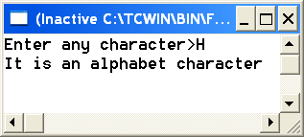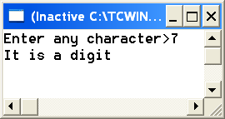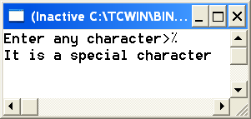

Question 3: (10 points)
Write a C function that receives a real value (input argument) and returns 3 results (using output arguments not printing). The 3 results are as follows:
- The sign ‘+’ (if the value positive), (‘-‘ if the value is negative, blank ‘ ‘ if value is 0.
- The integer part of the value
- The fraction part of the value
For example if the value received is -7.89, then your function will return ‘-‘, 7, and 0.89 for the 3 output arguments indicated above.
Don’t write the main function and include statements:

Question 4 (15 points):
Write a C program that declares a 2-D array of integer values with 5 rows and 4 columns and a 1-D array sumcols to store the sum of each column of the 2-D array. Your program will do the following:
- Reads the values from a file “data.txt” row by row (the file contains exactly 20 values) and store them in the 2-D array.
- Computes the sum of each column of the 2-D array and store the results in the 1-d array sumcols in the corresponding locations i.e. first element of sumcols contains sum of first column of 2-D array and so on.
- Prints the sum of each column.
Shown below is an example of “data.txt” file with program execution.
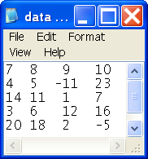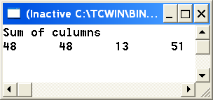

Question 5 (20 points)
Write a program containing 2 functions readText and main function.
readText will receive 2 parameters; a 2-D array to store the text and the number of lines (nlines) in the text.
The main function will declare a 2-D array text (10 rows and 81 columns) and 1-D array lines (801 elements). Your program will ask the user to enter how many lines to type. It will read the value and put it in nlines variable, then it will call readText function to read the text and put it in the 2-D array text. Your program will transfer the text read from 2-D array text to 1-D array lines as follows:
- copy the lines from text array to lines array in reverse order i.e. starting from the last line until first line.
- Each line is written in reverse order i.e. starting from the last character to the first one.The null character is not part of the string.
The transfer of characters from 2-D array to 1-D array is done using nested loops. Then your program will print the reversed text.
A sample execution of your program is shown below:
